Ex. No. 2 Implementation of fork (), exec () and wait () System Calls

PROGRAM:

#include <stdio.h>
#include <stdlib.h>
#include <unistd.h>
#include <sys/wait.h>
int main()
{
pid_t pid;
int status;

printf("Parent process: PID = %d\n", getpid());

pid = fork();

if (pid < 0) {
/* fork failed */
perror("fork failed");
exit(1);
}
else if (pid == 0) {
/* Child process */
printf("Child process: PID = %d, Parent PID = %d\n",
getpid(), getppid());
printf("Child is about to execute 'ls -l' using execlp()\n");

execlp("ls", "ls", "-l", NULL);

/* execlp only returns if it fails */
perror("execlp failed");
exit(1);
}
else {
/* Parent process */
printf("Parent waiting for child (PID = %d) to finish...\n", pid);
wait(&status);

if (WIFEXITED(status))
printf("Child terminated normally with exit code %d\n",
WEXITSTATUS(status));
else
printf("Child terminated abnormally\n");

printf("Parent process finished execution.\n");
}

return 0;
}

OUTPUT:
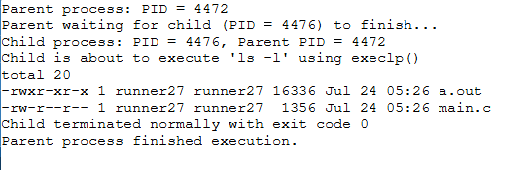

Ex. No. 3 File Copy using open (), read () and write () System Calls

PROGRAM:
#include <stdio.h>
#include <stdlib.h>
#include <unistd.h>
#include <fcntl.h>
#include <sys/stat.h>

#define BUF_SIZE 1024

int main(int argc, char *argv[])
{
int src_fd, dest_fd;
ssize_t n_read;
char buffer[BUF_SIZE];
char src_name[100], dest_name[100];

if (argc == 3) {
/* file names supplied on command line */
snprintf(src_name, sizeof(src_name), "%s", argv[1]);
snprintf(dest_name, sizeof(dest_name), "%s", argv[2]);
} else {
printf("Enter source file name: ");
scanf("%99s", src_name);
printf("Enter destination file name: ");
scanf("%99s", dest_name);
}

/* Open source file in read-only mode */
src_fd = open(src_name, O_RDONLY);
if (src_fd < 0) {
perror("Error opening source file");
exit(1);
}

/* Create/open destination file in write mode with rw-r--r-- permission */
dest_fd = open(dest_name, O_WRONLY | O_CREAT | O_TRUNC, 0644);
if (dest_fd < 0) {
perror("Error opening destination file");
close(src_fd);
exit(1);
}

/* Read from source and write to destination in chunks */
while ((n_read = read(src_fd, buffer, BUF_SIZE)) > 0) {
if (write(dest_fd, buffer, n_read) != n_read) {
perror("Error writing to destination file");
close(src_fd);
close(dest_fd);
exit(1);
}
}

if (n_read < 0)
perror("Error reading source file");
else
printf("File '%s' copied to '%s' successfully.\n", src_name, dest_name);

close(src_fd);
close(dest_fd);
return 0;
}

OUTPUT:
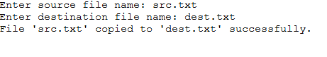

Ex. No. 4 CPU Scheduling - First Come First Serve (FCFS)

PROGRAM:
#include <stdio.h>
int main()
{
int n, i;
int bt[20], at[20], wt[20], tat[20];
float total_wt = 0, total_tat = 0;

printf("Enter number of processes: ");
scanf("%d", &n);

printf("Enter Arrival Time and Burst Time for each process:\n");
for (i = 0; i < n; i++) {
printf("P%d - Arrival Time: ", i + 1);
scanf("%d", &at[i]);
printf("P%d - Burst Time: ", i + 1);
scanf("%d", &bt[i]);
}

/* Processes are serviced strictly in the order given (FCFS order).
completion_time keeps track of when the CPU becomes free. */
int completion_time = 0;
printf("\nProcess\tAT\tBT\tWT\tTAT\n");
for (i = 0; i < n; i++) {
if (completion_time < at[i])
completion_time = at[i]; /* CPU idle until process arrives */

wt[i] = completion_time - at[i];
completion_time += bt[i];
tat[i] = completion_time - at[i];

total_wt += wt[i];
total_tat += tat[i];
printf("P%d\t%d\t%d\t%d\t%d\n", i + 1, at[i], bt[i], wt[i], tat[i]);
}

printf("\nAverage Waiting Time = %.2f\n", total_wt / n);
printf("Average Turnaround Time = %.2f\n", total_tat / n);

return 0;
}

OUTPUT:

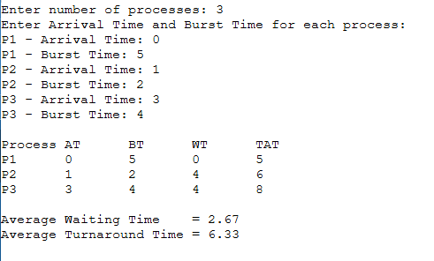

Ex. No. 5 CPU Scheduling - Shortest Job First (SJF), Non-Preemptive

PROGRAM:
#include <stdio.h>

int main()
{
int n, i;
int bt[20], at[20], wt[20], tat[20], done[20];
float total_wt = 0, total_tat = 0;
int completed = 0, current_time = 0;

printf("Enter number of processes: ");
scanf("%d", &n);

printf("Enter Arrival Time and Burst Time for each process:\n");
for (i = 0; i < n; i++) {
printf("P%d - Arrival Time: ", i + 1);
scanf("%d", &at[i]);
printf("P%d - Burst Time: ", i + 1);
scanf("%d", &bt[i]);
done[i] = 0;
}

while (completed != n) {
int idx = -1;
int min_bt = 1000000;

/* Among the processes that have arrived and are not done,
pick the one with the smallest burst time */
for (i = 0; i < n; i++) {
if (!done[i] && at[i] <= current_time) {
if (bt[i] < min_bt) {
min_bt = bt[i];
idx = i;
}
}
}

if (idx == -1) {
/* No process has arrived yet, CPU is idle */
current_time++;
continue;
}

wt[idx] = current_time - at[idx];
current_time += bt[idx];
tat[idx] = current_time - at[idx];
done[idx] = 1;
completed++;
}

printf("\nProcess\tAT\tBT\tWT\tTAT\n");
for (i = 0; i < n; i++) {
total_wt += wt[i];
total_tat += tat[i];
printf("P%d\t%d\t%d\t%d\t%d\n", i + 1, at[i], bt[i], wt[i], tat[i]);
}

printf("\nAverage Waiting Time = %.2f\n", total_wt / n);
printf("Average Turnaround Time = %.2f\n", total_tat / n);

return 0;
}

OUTPUT:
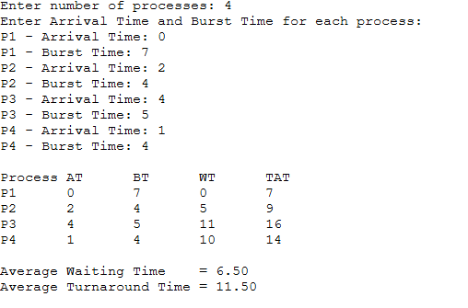

Ex. No. 6 CPU Scheduling - Round Robin

PROGRAM:
#include <stdio.h>
int main()
{
int n, i, tq;
int bt[20], at[20], rem_bt[20], wt[20], tat[20];
float total_wt = 0, total_tat = 0;

printf("Enter number of processes: ");
scanf("%d", &n);

printf("Enter Arrival Time and Burst Time for each process:\n");
for (i = 0; i < n; i++) {
printf("P%d - Arrival Time: ", i + 1);
scanf("%d", &at[i]);
printf("P%d - Burst Time: ", i + 1);
scanf("%d", &bt[i]);
rem_bt[i] = bt[i];
}

printf("Enter Time Quantum: ");
scanf("%d", &tq);
int current_time = 0, completed = 0;
int queue[1000], front = 0, rear = 0;
int in_queue[20] = {0};

/* Enqueue all processes that arrive at time 0 */
for (i = 0; i < n; i++) {
if (at[i] <= current_time && !in_queue[i]) {
queue[rear++] = i;
in_queue[i] = 1;
}
}

while (completed != n) {
if (front == rear) {
/* Queue empty - advance time to next arrival */
current_time++;
for (i = 0; i < n; i++)
if (at[i] <= current_time && !in_queue[i] && rem_bt[i] > 0) {
queue[rear++] = i;
in_queue[i] = 1;
}
continue;
}

int idx = queue[front++];

if (rem_bt[idx] > tq) {
current_time += tq;
rem_bt[idx] -= tq;
} else {
current_time += rem_bt[idx];
wt[idx] = current_time - at[idx] - bt[idx];
tat[idx] = current_time - at[idx];
rem_bt[idx] = 0;
completed++;
}

/* Enqueue any new arrivals during this time slice (before re-adding idx) */
for (i = 0; i < n; i++)
if (at[i] <= current_time && !in_queue[i] && rem_bt[i] > 0) {
queue[rear++] = i;
in_queue[i] = 1;
}

/* Re-add current process at the back of the queue if not finished */
if (rem_bt[idx] > 0)
queue[rear++] = idx;
}

printf("\nProcess\tAT\tBT\tWT\tTAT\n");
for (i = 0; i < n; i++) {
total_wt += wt[i];
total_tat += tat[i];
printf("P%d\t%d\t%d\t%d\t%d\n", i + 1, at[i], bt[i], wt[i], tat[i]);
}

printf("\nAverage Waiting Time = %.2f\n", total_wt / n);
printf("Average Turnaround Time = %.2f\n", total_tat / n);

return 0;
}

OUTPUT:

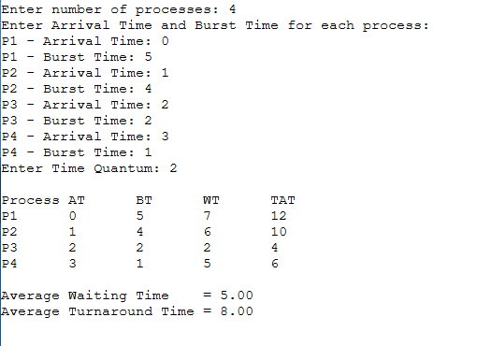

Ex. No. 7 CPU Scheduling - Priority Scheduling (Non-Preemptive)

PROGRAM:
#include <stdio.h>
int main()
{
int n, i;
int bt[20], at[20], pr[20], wt[20], tat[20], done[20];
float total_wt = 0, total_tat = 0;
int completed = 0, current_time = 0;

printf("Enter number of processes: ");
scanf("%d", &n);

printf("Enter Arrival Time, Burst Time and Priority (lower value = higher priority):\n");
for (i = 0; i < n; i++) {
printf("P%d - Arrival Time: ", i + 1);
scanf("%d", &at[i]);
printf("P%d - Burst Time: ", i + 1);
scanf("%d", &bt[i]);
printf("P%d - Priority: ", i + 1);
scanf("%d", &pr[i]);
done[i] = 0;
}

while (completed != n) {
int idx = -1;
int best_pr = 1000000;

/* Among arrived, unfinished processes, pick the one with the
highest priority (smallest priority number); break ties by
arrival time */
for (i = 0; i < n; i++) {
if (!done[i] && at[i] <= current_time) {
if (pr[i] < best_pr ||
(pr[i] == best_pr && idx != -1 && at[i] < at[idx])) {
best_pr = pr[i];
idx = i;
}
}
}

if (idx == -1) {
current_time++;
continue;
}

wt[idx] = current_time - at[idx];
current_time += bt[idx];
tat[idx] = current_time - at[idx];
done[idx] = 1;
completed++;
}

printf("\nProcess\tAT\tBT\tPriority\tWT\tTAT\n");
for (i = 0; i < n; i++) {
total_wt += wt[i];
total_tat += tat[i];
printf("P%d\t%d\t%d\t%d\t\t%d\t%d\n", i + 1, at[i], bt[i], pr[i], wt[i], tat[i]);
}

printf("\nAverage Waiting Time = %.2f\n", total_wt / n);
printf("Average Turnaround Time = %.2f\n", total_tat / n);

return 0;
}

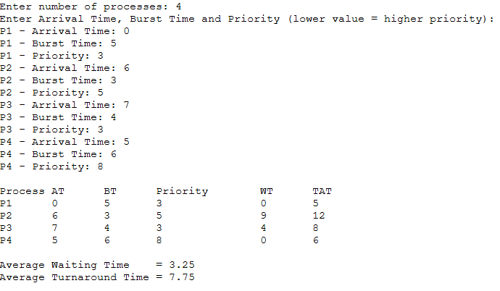
OUTPUT:

Ex. No. 8 Process Synchronization - Producer-Consumer Problem using Semaphores

PROGRAM:
#include <stdio.h>
#include <stdlib.h>
#include <unistd.h>
#include <pthread.h>
#include <semaphore.h>
#define BUFFER_SIZE 5
#define ITEMS_TO_PRODUCE 10
int buffer[BUFFER_SIZE];
int in = 0, out = 0;

sem_t empty; /* counts empty slots */
sem_t full; /* counts filled slots */
pthread_mutex_t mutex; /* protects buffer access */
void *producer(void *arg)
{
int item;
for (item = 1; item <= ITEMS_TO_PRODUCE; item++) {
sem_wait(&empty); /* wait for an empty slot */
pthread_mutex_lock(&mutex); /* enter critical section */
buffer[in] = item;
printf("Producer produced item %d at slot %d\n", item, in);
in = (in + 1) % BUFFER_SIZE;
pthread_mutex_unlock(&mutex); /* leave critical section */
sem_post(&full); /* signal a new filled slot */
usleep(100000); /* simulate production time */
}
return NULL;
}
void *consumer(void *arg)
{
int item;
for (int count = 1; count <= ITEMS_TO_PRODUCE; count++) {
sem_wait(&full); /* wait for a filled slot */
pthread_mutex_lock(&mutex); /* enter critical section */
item = buffer[out];
printf("\tConsumer consumed item %d from slot %d\n", item, out);
out = (out + 1) % BUFFER_SIZE;
pthread_mutex_unlock(&mutex); /* leave critical section */
sem_post(&empty); /* signal a new empty slot */
usleep(150000); /* simulate consumption time */
}
return NULL;
}
int main()
{
pthread_t prod_thread, cons_thread;
sem_init(&empty, 0, BUFFER_SIZE); /* initially all slots empty */
sem_init(&full, 0, 0); /* initially no slots filled */
pthread_mutex_init(&mutex, NULL);
pthread_create(&prod_thread, NULL, producer, NULL);
pthread_create(&cons_thread, NULL, consumer, NULL);
pthread_join(prod_thread, NULL);
pthread_join(cons_thread, NULL);
sem_destroy(&empty);
sem_destroy(&full);
pthread_mutex_destroy(&mutex);

printf("\nAll items produced and consumed successfully.\n");
return 0;
}

OUTPUT:
